A4 - GUI Calculator

Assignment Submission

By: Connor Goodwin

W#: W0488245

Date: 2025-09-30

[10%] test on 3 different screen sizes

Small Phone: API: 36, Screensize: 720x1280:

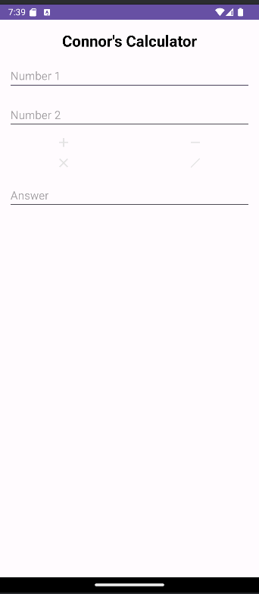

Pixel 7a, API: 34, Screensize: 1080x2400

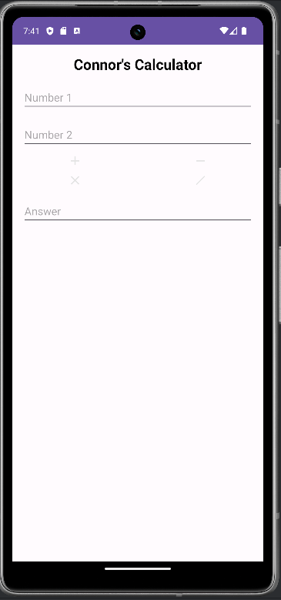

Medium Phone, API: 35, Screensize: 1080x2600

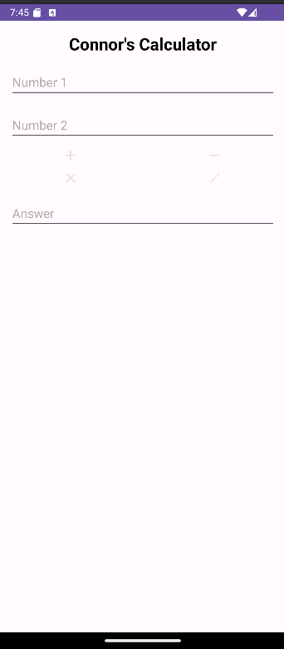

[10%] 2 different API-levels (23, 22, 21, ...any 2 different)

As shown above.

[10%] at least one is Landscape, at least one is Portrait.

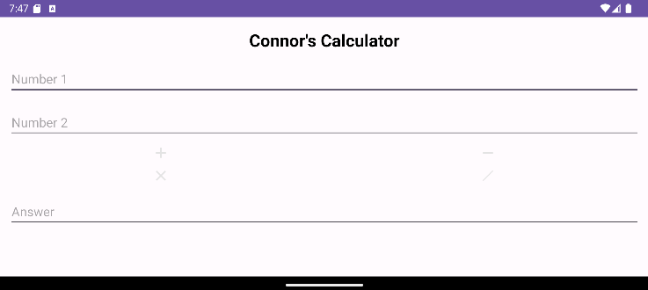

[10%] You decide exactly which sizes and API levels to use, but it needs to be detectable per the next section...with the following features...

As seen above.

[10%] Use graphics for your +,-,\*,/ buttons such that they are the proper size for the format. (can be a Vector Graphic)

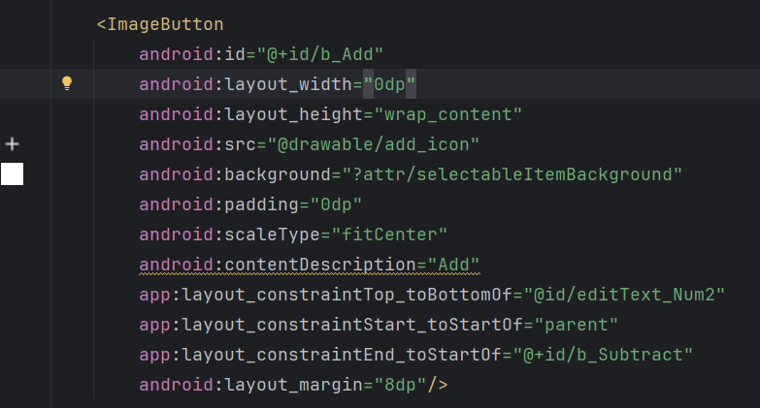

[10%] Create a graphic (to display with the calculator) with your name that changes density to match the screen (similar to my example; or, can be a Vector Graphic)

Just did a txt name

[10%] Create your own mipmap/launcher.png file to match the different screen densities.

 Image of the launcher png on the phone home screen.